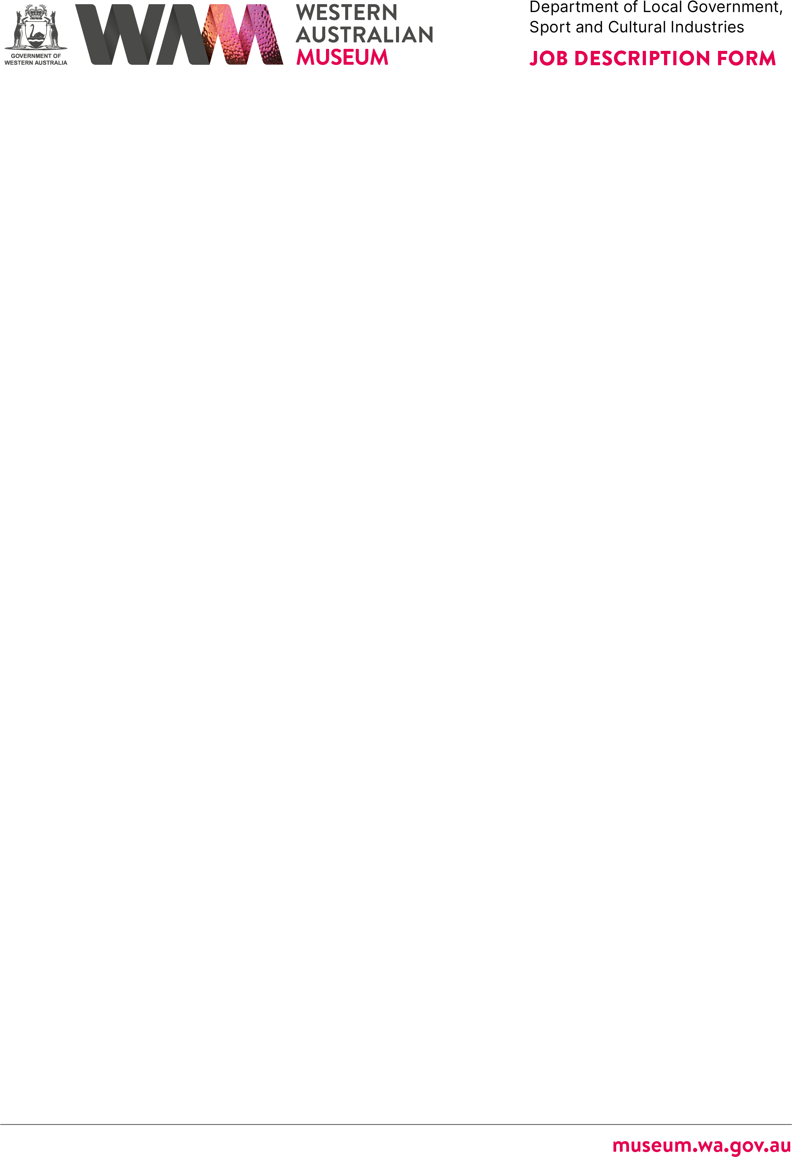

# ABOUT THE WESTERN AUSTRALIAN MUSEUM

The WA Museum’s mission is to inspire curiosity to explore the past, question the present and shape the future.

Our work is diverse and collaborative; it is local, national and global. We aspire to be a valued, used, and admired organisation by all Western Australians and the world.

WA Museum manages eight locations throughout Western Australia, including the award winning Boola Bardip in Perth Cultural Centre. We have a team of dedicated

Curators undertaking a wide range of research and caring for more than eight million objects for the benefit of future generations.

The Museum is a Statutory Authority within the Department of Creative Industries, Tourism, and Sport (CITS).

|  |  |
| --- | --- |
| **DETAILS** |  |
| **Position Title** | **Position Number** |
| Administrative Assistant | 14275 |
| **Classification Level** | **Award/Agreement** |
| Level 2 (L2) | Public Service Award 1992 / PSGO CSA GA |
| **Directorate** | **Branch/Team** |
| Creative & Regional Development | Museum of the Great Southern, Albany |
| **Physical Location/s** |  |
| Albany |  |

# REPORTING RELATIONSHIPS

## Position reports to

Regional Manager, Albany Museum – Level 7

## Positions reporting to this position

* Nil



# PURPOSE OF THE POSITION

Provides confidential secretarial and administrative support to Museum of the Great Southern/ WA Museum.

# STATEMENT OF DUTIES

## Secretarial

* + Answers and directs telephone calls. Responds to enquiries competently and efficiently, including professional stakeholder liaison on behalf of the Manager. Receives visitors and provides tea/coffee.
  + Arranges meetings with internal and external stakeholders including the preparation of agenda and other meeting papers; set up of meeting rooms/teleconference and taking meeting Minutes where required.
  + Arranges itinerary, travel, visas and accommodation for staff, as required.



* + Maintains confidential files and correspondence.
  + Types letters, proof-reads, and tracks correspondence.
  + Maintains tidiness of the office.

## Administrative

* + Provides day–to-day administrative support, including quality word processing, and undertaking basic financial and human resources processes.
  + Performs research on requests/enquiries and analysis of documents; and coordinates information, as required.
  + Database management.
  + Prepares PowerPoint presentations.
  + Undertakes general records and file management utilising the Museums’ electronic information management system (e.g., TRIM).
  + Collects and distributes mail daily.
  + Other duties as required with respect to the scope of the position.

# WORK RELATED REQUIREMENTS

## Essential

1. Ability to work both independently and as a part of a team.
2. Demonstrated high level of secretarial skills including word processing and data base operations.
3. Demonstrated knowledge of standard office procedures.
4. Demonstrated high level of verbal and written communication and interpersonal skills.
5. Demonstrated organisational and co-ordination skills.
6. Ability to work with minimal supervision and to exercise initiative and discretion.

## Desirable

1. Knowledge of government procedures including preparation of Ministerial correspondence.
2. Knowledge and experience of Content Manager (TRIM) records management system.

GOVERNMENT OF WESTERN AUSTRALIA

A

**WESTERN AUSTRALIAN MUSEUM**

Department of Local Government, Sport and Cultural Industries

**JOB DESCRIPTION FORM**

# SPECIAL CONDITIONS

* + Nil.

# APPOINTMENT IS SUBJECT TO

* + Eligibility to Work in Australia.
  + A current (within six months) National Police Clearance Certificate.

**museum.wa.gov.au**