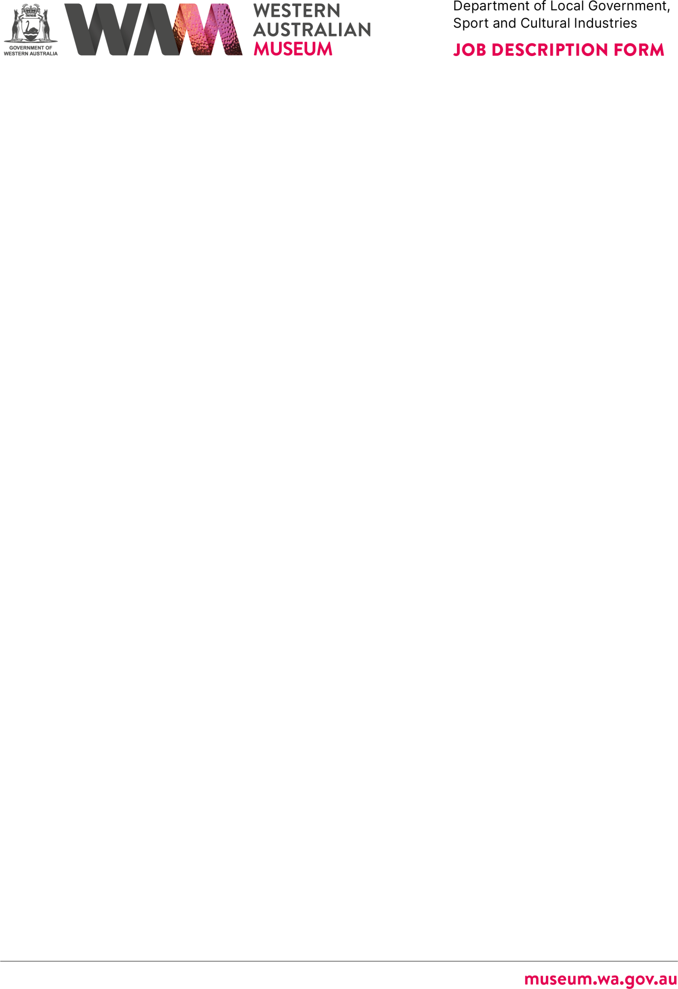



# ABOUT THE WESTERN AUSTRALIAN MUSEUM

The WA Museum’s mission is to inspire curiosity to explore the past, question the present and shape the future.

Our work is diverse and collaborative; it is local, national and global. We aspire to be valued, used and admired organisation by all Western Australians and the world.

WA Museum manages eight locations throughout Western Australia, including the award winning Boola Bardip in Perth Cultural Centre. We have a team of dedicated curators undertaking a wide range of research and caring for more than eight million objects for the benefit of future generations.

The Museum is a Statutory Authority within the Department of Local Government, Sport and Cultural Industries (DLGSC).







# DETAILS

## Position Title Position Number

Senior Human Resource Officer

**Classification Level** Level 4 (L4) **Directorate**

Corporate and Strategy

## Physical Location/s

WA Museum Boola Bardip, Perth

# REPORTING RELATIONSHIPS

13141

## Award/Agreement

Public Service Award 1992 / PSGO CSA GA

## Branch/Team

Corporate and Strategy



## Position reports to

Manager Human Resources, L7 **Positions reporting to this position**

* Nil

# PURPOSE OF THE POSITION

Contributes to a broad range of human resource activities, including strategic workforce and organisational development activities. This role provides a comprehensive advisory and consultancy service to WA Museum staff.

# STATEMENT OF DUTIES

* Provides a contemporary and customer-focused consultancy service to managers and staff on human resource matters, including recruitment and selection, classification determination and establishment, redeployment, learning and development and reporting.
* Assists in the development and review of human resource-related policies and procedures in accordance with industrial Awards and Agreements and relevant legislation.
* Monitors and maintains records (and provides advice where necessary) on specific HR- related matters including, secondary employment declarations, conflict of interest, Working with Children, work placements and other areas as required.



* Administer the online Learning Management System (GO1) and ensure the currency of learning modules and programs that meet the needs of the organisation.
* Assists in the coordination of the HR Intranet page (Pulse) ensuring information is current and accurate.
* Assists in developing, implementing and monitoring human resource-related projects.
* Provide customer-focused advice and support to employees on HR systems.
* Produces regular and ad-hoc reports to stakeholders to deliver information to meet HR reporting requirements including the addressing of trends, issues, capability and resourcing gaps.

Other duties as required with respect to the scope of the position.

# WORK RELATED REQUIREMENTS

## Essential

1. Demonstrated relevant skills, knowledge and experience in providing a broad human resource consultancy and advisory service.
2. Knowledge and ability to successfully implement and/or undertake the administration of contemporary learning management systems, including the development and maintenance of e-learning content.
3. Demonstrated experience in planning and prioritising tasks to deliver required outcomes in an environment with competing demands and deadlines, including managing a diverse workload, and the planned development and management of projects.
4. Well-developed interpersonal and communication (verbal and written) skills that enable successful interaction and cooperation with Executives and senior managers across a variety of levels and the ability to work effectively in a team environment providing a customer-focused service.

# APPOINTMENT IS SUBJECT TO

* + Eligibility to Work in Australia.
  + A current (within six months) National Police Clearance Certificate.