# ABOUT T HE WEST ERN AUST RALIAN MUSEUM

The WA Museum’s mission is to inspire curiosity to explore the past, question the present and shape the future.

Our work is diverse and collaborative; it is local, national and global. We aspire to be valued, used and admired organisation by all Western Australians and the world.

WA Museum manages eight locations throughout Western Australia, including the award winning Boola Bardip in Perth Cultural Centre. We have a team of dedicated curators undertaking a wide range of research and caring for more than eight million objects for the benefit of future generations.

The Museum is a Statutory Authority within the Department of Local Government, Sport and Cultural Industries (DLGSC).









# DETAILS

## Position Title Position Number

Marketing and Campaign Officer 11994

## Classification Level Award/Agreement

Level 4 (L4) Public Service Award 1992 / PSGO CSA GA

## Directorate Branch/Team

Engagement Engagement / Marketing and Audience

Development

## Physical Location/s

WA Museum Boola Bardip, Perth

# REPORTING RELATIONSHIPS

## Position reports to

Senior Marketing and Campaigns Coordinator, L5

## Positions reporting to this position

* Nil

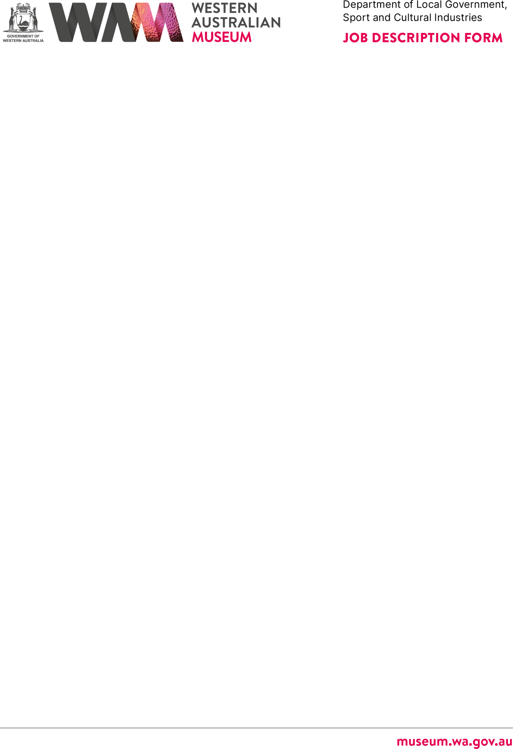

# PURPOSE OF THE POSITION

The role assists with the following key areas:

* Brand implementation and marketing campaign planning, implementation, and monitoring for all WA Museum brands, with strong focus on temporary exhibitions and special programs and events.
* Audience development - communicating with existing audiences and driving growth with new audiences to increase engagement across all channels.
* The position works collaboratively with cross-functional teams to build campaigns and report and deliver key organisational outcomes.

# STATEMENT OF DUTIES

* In conjunction with the Senior Marketing and Campaigns Coordinator, co-ordinates the WA Museum’s marketing and promotional activities to increase awareness, meet visitation and budget targets and promote the Museum’s diverse range of products, programs, exhibitions and services to a range of audiences.



* Works with the marketing, communications, social and digital teams to deliver high quality campaigns, providing advice on content planning, advertising, search and re- marketing.
* Prepares marketing plans and develops a range of promotional materials, working with internal and external contractors.
* Evaluates effectiveness of marketing campaigns against business targets and visitation reports.
* Effectively liaises with key stakeholders to ensure key deliverables are met on time within budget.
* Assists the Senior Marketing and Campaigns Coordinator with budgeting and financial administration for the marketing department.
* Other duties as required with respect to the scope of the position.

# WORK RELATED REQUIREMENTS

## Essential

1. Demonstrated experience developing, implementing and evaluating integrated marketing campaigns, including the selection of appropriate channels and key messages for target audiences.
2. Experience implementing social and digital marketing campaigns, including planning and evaluating content for digital ads, search and re-marketing strategies.
3. Highly developed interpersonal, verbal and written communication skills to deliver exceptional marketing campaigns, and to effectively liaise with a wide range of stakeholders.
4. Strong organisational, project management and decision-making skills to deliver multiple projects within budget and allocated timeframes.
5. Demonstrated ability to work proactively and creatively within a team-based environment.

## Desirable

1. Tertiary qualifications (or extensive professional experience) in a marketing, advertising or a related field.



# SPECIAL CONDITIONS

* + Will be required to occasionally work outside normal business hours.

# APPOINTMENT IS SUBJECT TO

* + Eligibility to Work in Australia.
  + A current (within six months) National Police Clearance will be required.