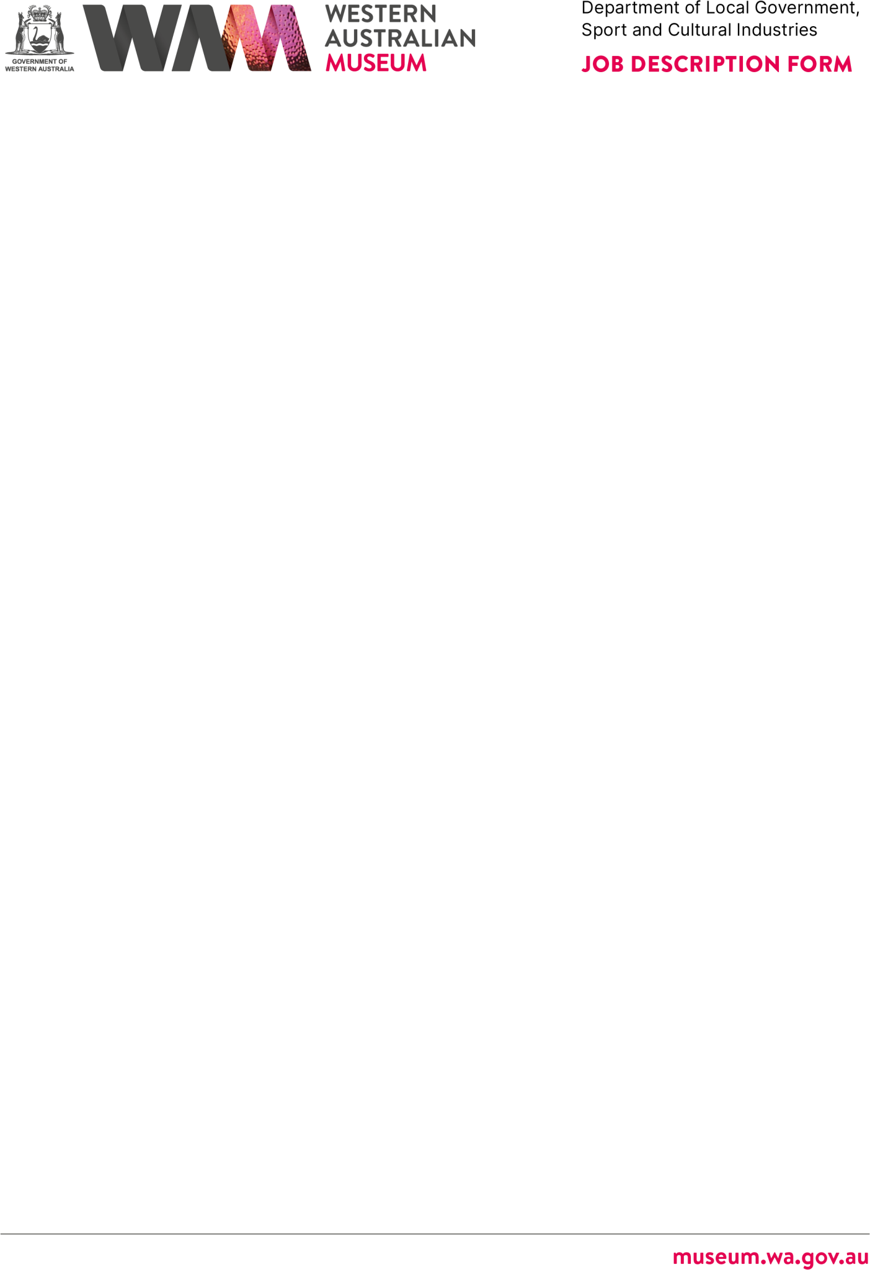

# ABOUT THE WESTERN AUSTRALIAN MUSEUM

The WA Museum’s mission is to inspire curiosity to explore the past, question the present and shape the future.

Our work is diverse and collaborative; it is local, national and global. We aspire to be a valued, used, and admired organisation by all Western Australians and the world.

WA Museum manages eight locations throughout Western Australia, including the award-winning Boola Bardip in the Perth Cultural Centre. We have a team of dedicated curators undertaking a wide range of research and caring for more than eight million objects for the benefit of future generations.

The Museum is a Statutory Authority within the Department of Local Government, Sport and Cultural Industries (DLGSC).

|  |  |
| --- | --- |
| **DETAILS** |  |
| **Position Title** | **Position Number**  16734  **Award/Agreement**  Public Service Award 1992 / PSCSAA  **Branch/Team**  Engagement / Marketing and Audience Development |
| Audience Research Analyst |
| **Classification Level** |
| Level 4 |
| **Directorate** |
| Engagement |
| **Physical Location/s** |  |
| WA Museum Boola Bardip, Perth |  |

# REPORTING RELATIONSHIPS

## Position reports to

Manager Marketing and Audience Development, L7

## Positions reporting to this position

* Nil

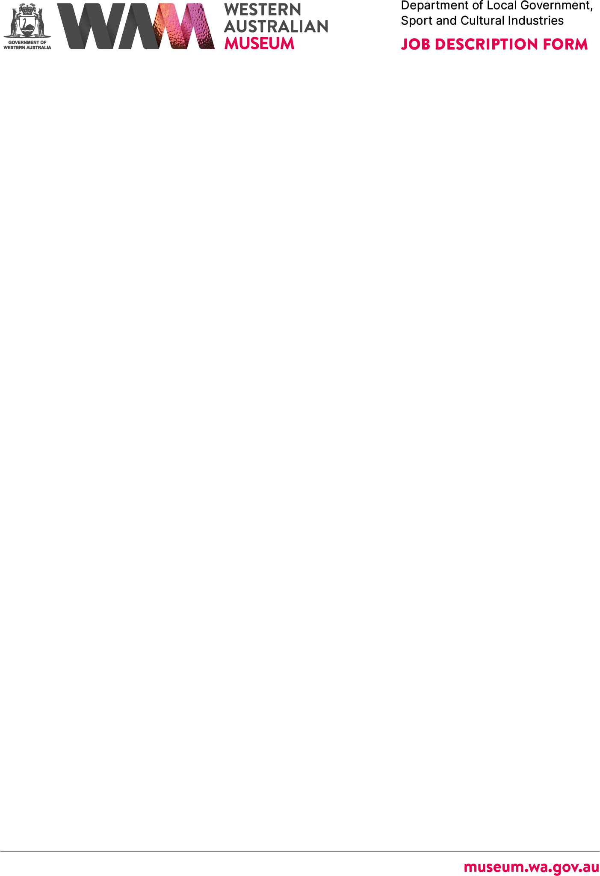

# PURPOSE OF THE POSITION

Capture, analyse and interpret data from a range of data sources to gain audience insights, preferences and trends to inform the development of targeted strategies, support initiatives, enhance engagement and support organisational decision making.

# STATEMENT OF DUTIES

## Visitation Data Capture and Reporting

* Record, maintain, and monitor visitor data across six WA Museum sites - including general admission, special exhibitions, and programs.
* Coordinate the collection and analysis of visitation data from various sources including the Tessitura ticketing system, thermal counters and venue management software.
* Aggregate, analyse, and communicate audience data insights to internal and external stakeholders.
* Support the development and improvement of reporting dashboards for the WA Museum.



* Maintain key performance indicator (KPI) data for auditing, executive management, and reporting to the board and in annual reports, maintaining a high degree of accuracy.

## Audience Research

* Co-ordinate the design, implementation, and reporting of a range of visitor research projects to gain insights into new and existing WA Museum audiences, including Visitor360 surveys, formative research, and summative evaluations to support the development of permanent and special exhibitions and programs.
* Collaborate with internal and external stakeholders to ensure research findings are communicated effectively and applied to meet audience needs and organisational goals.
* Prepare and deliver research and visitation reports, including data collection, analysis, and final reporting for key stakeholders.

## Administration and Budget Management:

* Assist the Manager Marketing and Audience Development with budget management and financial administration.
* Assist the Manager Marketing and Audience Development with other duties as required.
* Other duties as required with respect to the scope of the position.

# WORK RELATED REQUIREMENTS

## Essential

1. Strong analytical skills with the ability to capture, maintain and interpret high quality data and provide insightful recommendations to inform decision-making.
2. Proven experience in managing qualitative and quantitative research projects, ensuring comprehensive and actionable results.
3. Strong written and verbal communication skills, with the ability to present findings clearly and effectively to diverse audiences, including key stakeholders.
4. Exceptional attention to detail and the ability to juggle multiple tasks and priorities efficiently in a fast-paced environment.
5. Experience at identifying key trends, challenges, and opportunities within audience data, and offering solutions to drive continuous improvement.
6. Proactive and creative problem-solving abilities, with a strong track record of collaborating in team environments to meet objectives and overcome challenges.
7. Advanced proficiency in Microsoft Word, Excel, and PowerPoint, including Power BI, with the aptitude to quickly learn and effectively utilise new software and tools.



# SPECIAL CONDITIONS

* + Nil

# APPOINTMENT IS SUBJECT TO

* + Eligibility to Work in Australia.
  + A current (within six months) National Police Clearance Certificate.