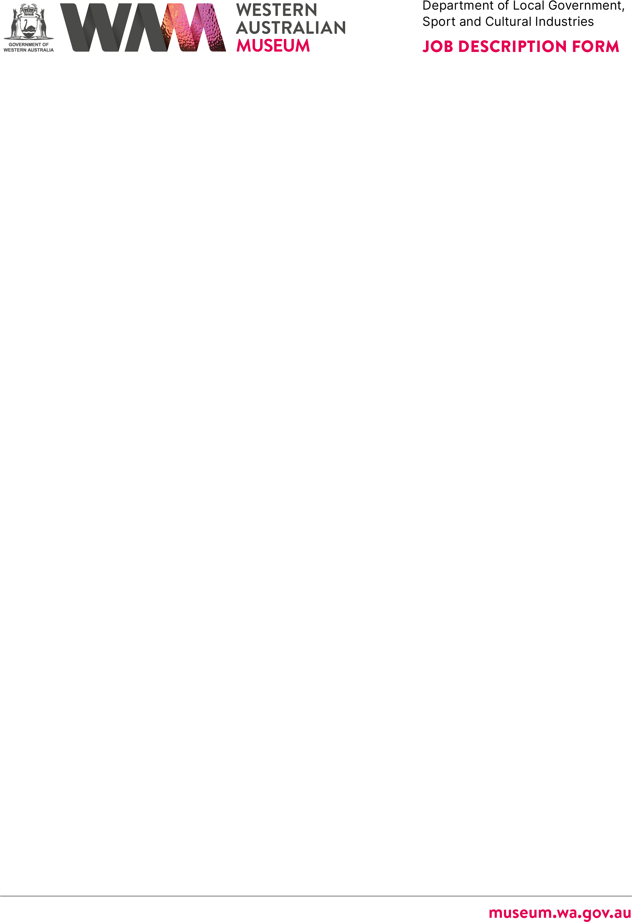



# ABOUT THE WESTERN AUSTRALIAN MUSEUM

The WA Museum’s mission is to inspire curiosity to explore the past, question the present and shape the future.

Our work is diverse and collaborative; it is local, national and global. We aspire to be a valued, used, and admired organisation by all Western Australians and the world.

WA Museum manages eight locations throughout Western Australia, including the

award-winning Boola Bardip in the Perth Cultural Centre. We have a team of dedicated curators undertaking a wide range of research and caring for more than eight million

objects for the benefit of future generations.

The Museum is a Statutory Authority within the Department of Local Government, Sport and Cultural Industries (DLGSC).







|  |  |
| --- | --- |
| **DETAILS** |  |
| **Position Title** | **Position Number** |
| Supervisor Visitor Services | 14681 |
| **Classification Level** | **Award/Agreement** |
| ATT/S | Government Services (Misc) General Agreement 2024 |
| **Directorate** | **Branch/Team** |
| Engagement | WA Museum Boola Bardip / Operations |
| **Physical Location/s** |  |
| WA Museum Boola Bardip, Perth |  |

# REPORTING RELATIONSHIPS

## Position reports to

Operations Manager, Level 5

## Positions reporting to this position

* Assistant Supervisor, A/SUP
* Visitor Services Officer G2, VSO2 (18x FTE)



# PURPOSE OF THE POSITION

Coordination of daily visitor services operations, including high presentation standards of exhibition areas, tour guiding, some public programs, admissions, customer service and public liaison. Ensures safety and security of the public and Museum Collection.

Coordination of rosters, timesheets, performance management, and administration and training requirements for the Visitor Services department.

# STATEMENT OF DUTIES

## Daily Staff Supervision and Site Operations:

* Monitors daily operating procedures for the Visitor Services department.
* Ensures that Visitor Services staff are provided with sufficient supervision, instruction, and equipment to enable them to perform their duties safely and effectively.



* Coordinates staffing, including the preparation of rosters, timesheet administration, special functions, exhibitions and events, and staff absences, in order to meet operational requirements.
* Assists the Site Manager, WA Museum Boola Bardip, with data collection.
* Coordinates Visitor Service staff including staff performance management, training, and recruitment, in consultation with the Operations Manager, WA Museum Boola Bardip .

## Public Liaison and Interpretation:

* Coordinates and implements interpretative experiences.
* Conducts interpretive experiences as required.
* Ensures that a high standard of service and hospitality is provided for visitors, clients, and stakeholders.
* Responds to verbal visitor enquiries and complaints in accordance with Museum procedure.

## Liaises With Other Departments and External Service Providers as Required:

* Coordinates procedures for opening, operations during opening hours and closing of the museum.
* Ensures that staff and visitor security and safety procedures are maintained in museum and associated buildings, including compliance with safe work practices and museum policy.
* Reports on incidents and accidents involving members of the public and/or staff.
* Acts as a Chief Warden, Assistant Warden, or Warden in emergency situations.

## Other Duties:

* Other duties as required, having regard for the skills, knowledge, and abilities of the employee
* Oversees admissions, cash handling, point-of-sale, and reconciliation procedures.
* Other duties as required with respect to the scope of the position.



# WORK RELATED REQUIREMENTS

## Essential

1. Demonstrated understanding of the importance of good customer service and the ability to engage with visitors and staff in a friendly and professional manner.
2. Demonstrated experience in team supervision.
3. Demonstrated high level of problem-solving skills, organisational and time- management skills, and using a range of computer applications.
4. Highly developed written and verbal communication skills, including conflict resolution.
5. Demonstrated leadership skills in a team environment.

## Desirable

1. Experience in point-of-sale duties and procedures and demonstrated understanding of the importance of following cash-handling procedures.
2. Qualifications or experience in a tourism or cultural heritage environment.

# SPECIAL CONDITIONS

* + Working outside of normal business hours and may be required to work weekend shifts on occasion.

# APPOINTMENT IS SUBJECT TO

* + Eligibility to Work in Australia.
  + A current (within 6 months) National Police Clearance Certificate.
  + A current Working with Children Check (WWCC) will be required.