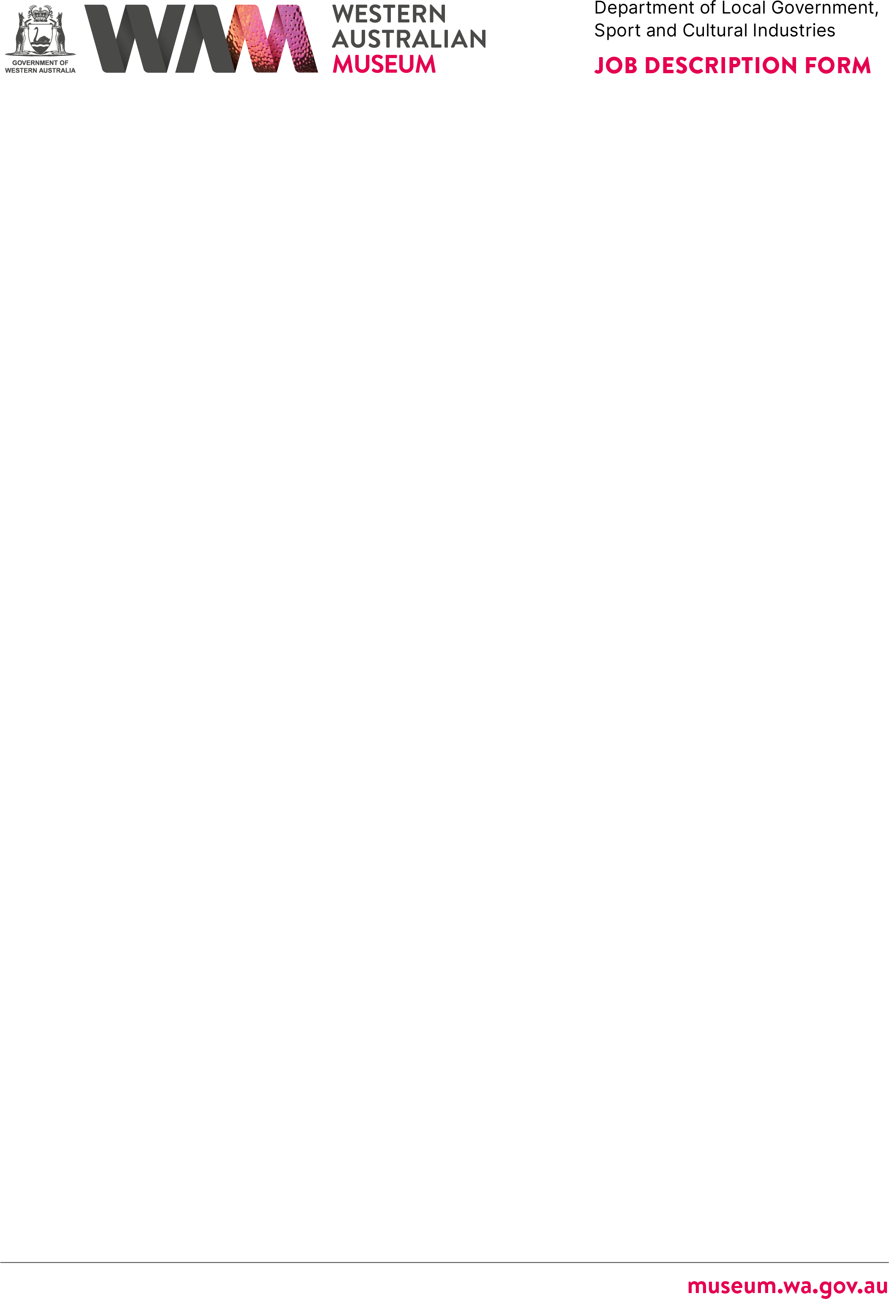



# ABOUT THE WESTERN AUSTRALIAN MUSEUM

The WA Museum’s mission is to inspire curiosity to explore the past, question the present and shape the future.

Our work is diverse and collaborative; it is local, national and global. We aspire to be valued, used and admired organisation by all Western Australians and the world.

WA Museum manages eight locations throughout Western Australia, including the award winning Boola Bardip in Perth Cultural Centre. We have a team of dedicated curators undertaking a wide range of research and caring for more than eight million objects for the benefit of future generations.

The Museum is a Statutory Authority within the Department of Local Government, Sport and Cultural Industries (DLGSC).







|  |
| --- |
| **DETAILS** |
| **Position Title Position Number**  Cleaner Various  **Classification Level Award/Agreement**  Level 1 (CLNR) Government Services (Misc) General Agreement 2025  **Directorate Branch/Team**  Engagement WA Museum Boola Bardip / Operations |

## Physical Location/s

WA Museum Boola Bardip, Perth

# REPORTING RELATIONSHIPS

## Position reports to

Assistant Supervisor, A/SUP

## Positions reporting to this position

* Nil



# PURPOSE OF THE POSITION

The role is responsible for providing a high standard of cleaning at the WA Museum Boola Bardip, Perth and Galleries.

# STATEMENT OF DUTIES

## Site Operations:

* Cleaning designated areas as outlined in the Museums Governing Standards.
* Use industrial and commercial cleaning equipment/machinery in a safe and efficient manner.
* Perform other duties as directed by the responsible Manager having regard for the skills, knowledge and abilities of the employee.
* Other duties as required with respect to the scope of the position.



# WORK RELATED REQUIREMENTS

## Essential

1. Demonstrated experience in commercial cleaning activities using a range of commercial grade cleaning agents and other products. Typical duties would include, but are not limited to, the following:
   * Cleaning and maintenance of a variety of floor surfaces (wood, tile, carpet, vinyl, concrete, etc).
   * Cleaning internal and external glass surfaces.
   * Cleaning and disinfecting wet areas (bathrooms, toilets, etc).
   * Cleaning and disinfecting food preparation areas.
   * Internal and external waste disposal.
   * Cleaning of external areas (paving, courtyards, decking).
2. Demonstrated experience and the ability to safely operate a variety of commercial cleaning appliances including, but not limited to:
   * Vacuum cleaners.
   * High-speed floor scrubbers and polishers.
   * Pressurised water cleaners.
   * Water extraction carpet shampoo machines.
3. Demonstrated ability to follow verbal and written instructions and work effectively as part of a team, with minimal supervision.
4. Demonstrated ability to comply with safe working practices and identify health and safety hazards, take suitable precautions, and report incidents.
5. Demonstrate physical capacity to perform the duties of the position.

## Desirable

1. Experience in hard floor stripping and sealing.
2. Experience with accessing Security systems.
3. Experience in cleaning function venues and commercial kitchens.



# SPECIAL CONDITIONS

* + Normal working hours may be 5:00am start including weekends and public holidays.
  + Weekend/Public holiday penalty rates apply as per Award/Agreement.
  + A pre-employment Medical Check will be required prior to commencement of employment.

# APPOINTMENT IS SUBJECT TO

* + Eligibility to Work in Australia.
  + A current (within six months) National Police Clearance Certificate.