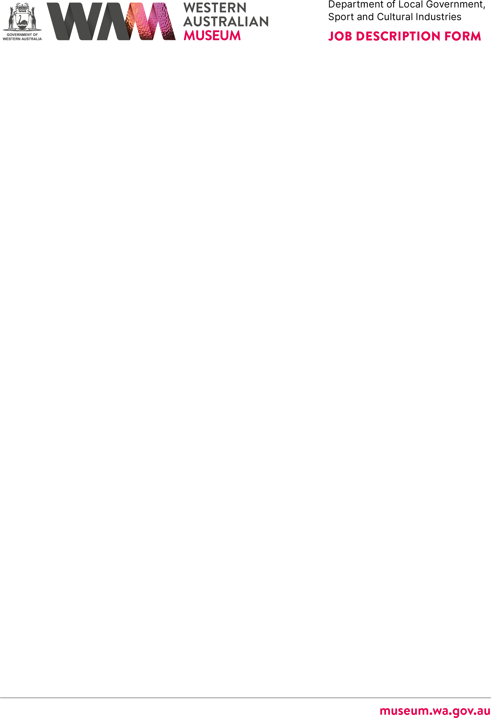



# ABOUT THE WESTERN AUSTRALIAN MUSEUM

The WA Museum’s mission is to inspire curiosity to explore the past, question the present and shape the future.

Our work is diverse and collaborative; it is local, national and global. We aspire to be valued, used and admired organisation by all Western Australians and the world.

WA Museum manages eight locations throughout Western Australia, including the award winning Boola Bardip in Perth Cultural Centre. We have a team of dedicated curators undertaking a wide range of research and caring for more than eight million objects for the benefit of future generations.

The Museum is a Statutory Authority within the Department of Local Government, Sport and Cultural Industries (DLGSC).







|  |  |
| --- | --- |
| **DETAILS** |  |
| **Position Title** | **Position Number** |
| Visitor Services Officer Grade 2 | 11866/11868/11880/11886/11889/15074/  15076/15077/15081/15141/15211/ |
| **Classification Level** | **Award/Agreement** |
| Visitor Services Officer Grade 2, Level 6 (VSO2) | Government Services (Misc) General Agreement 2021 |
| **Directorate** | **Branch/Team** |
| Engagement | Fremantle Museums / Operations |
| **Physical Location/s** |  |
| Fremantle Museums, Fremantle |  |

# REPORTING RELATIONSHIPS

## Position reports to

Supervisor Visitor Services, ATT/S

## Positions reporting to this position

* Nil



# PURPOSE OF THE POSITION

The VSO’s role is to:

* Provide a welcoming environment and high-quality experience for Museum visitors.
* Ensure the safety of visitors and staff within the Museum.
* Ensure the security of the Museum collection.

# STATEMENT OF DUTIES

## Provide visitors with a welcoming environment and a high-quality experience:

* Provide excellent customer service for visitors, responding to their needs in a professional, courteous and friendly manner.
* Provide advanced and specialised tours, interpretive programs, and assist with the delivery of education programs that contribute to visitors’ understanding and enjoyment of the Museum.



* Present information to visitors in an engaging and educational manner, ensuring accuracy and respect for the cultural and historical significance of exhibits.
* Gather visitor feedback, both positive and negative, to assist in improving visitors’ experiences.
* Acquire and continually build knowledge about the Museum’s exhibitions, displays, objects, buildings, commercial operations and public programs.
* Maintain a high standard of personal presentation and ensure the Museum precinct is well maintained. This includes but is not limited to cleaning and reporting maintenance issues.
* Accurate processing of sales associated with visitor services.
* Attend to shop and customers, and maintain an attractive retail environment.
* Attend to any problems with gallery multimedia, try to identify the problem to either resolve (through resetting or rebooting the system) or report for appropriate attention.
* Assist visitors to use the Museum’s Digital Platform.

## Support public events and functions:

* Assist with the setup of special events, functions and activities.
* Provide function and event tours, that may be presented in theme with the function or event.

## Provide a high standard of security and safety for visitors and the Museum precinct:

* Maintain the security of the Museum precinct, artefacts, objects and displays by patrolling (i.e. walking and standing) the Museum and monitoring security systems.
* Protect the safety of both visitors and staff in the Museum precinct.
* Provide timely recording and reporting of incidents and accidents.
* Provide leadership in emergency situations and if the Museum needs to be evacuated.
* Administer First Aid if required.



## Continually improve and develop, individually and within a team:

* Maintain and improve skills and knowledge through professional and performance development.
* Ensure a flexible and accommodating way of working that considers the overall needs of the work team and the Museum

Other duties as required with respect to the scope of the position.

# WORK RELATED REQUIREMENTS

## Essential

Visitor Services Officer (VSO) applicants must demonstrate their experience and ability in the following:

1. **Commitment to quality customer service**. VSO’s are ‘the face’ of the Museum. They deliver high-quality services to visitors or other staff and are expected to be friendly, polite and professional at all times. A VSO deals tactfully with people in sensitive situations so that customers feel respected and, if possible, satisfaction is maintained. A VSO determines the need to speak with visitors and/or, where appropriate, respects the visitor’s need to enjoy their visit unassisted.
2. **Commitment and ability to work well alone or within a team**. A VSO is able to work effectively in a team environment and on their own to ensure that the Museum’s priorities are met on any given day, in a safe and timely manner.
3. **Ability to learn, retain and implement procedures and information**. A VSO is required to learn and retain operational procedures and to implement them efficiently and effectively. This includes the handling of emergency situations. A VSO continuously improves their knowledge of and ability to share the Museum’s changing programs, collection and visiting exhibitions.
4. **Ability to maintain close observation of the environment in busy and quiet periods**. A VSO is able to assess various types of situations, including emergencies, and to respond to these appropriately, sometimes under pressure. A VSO must be discreet and vigilant in protecting the security and safety of Museum visitors, staff and the collection.



1. **Ability to carry out regular physical duties**. A VSO regularly patrols (i.e. walks and stands) the Museum for long periods of time and performs lock-up duties which may involve the operation of heavy doors. A VSO also regularly undertakes cleaning duties such as cleaning display cases, brass fixtures, vacuuming and mopping floors, as well as occasional moving of equipment, including furniture or heavy items for events.
2. **Strong computer and multimedia skills**. A VSO frequently uses software such as MS Office (Word, Excel) and email / internet technology. A VSO is also required to learn and operate current technology, such as multimedia used in the galleries, computerised sales and ticketing systems, as well as EFTPOS.
3. **Well-developed presentation and communication skills, delivering information in an engaging and educational way to diverse audiences**. A VSO maintains a positive approach to the many different people who visit and work in the Museum. They are vital in creating the Museum’s welcoming and inclusive environment. A VSO is comfortable speaking publicly to a group of people, uses initiative and conducts tours and assists visitors to understand and enjoy exhibition content.

## Desirable

It is desirable that Visitor Services Officer (VSO) applicants demonstrate their experience and ability in the following:

1. Fluency in a language other than English and/or Cultural sensitivity.
2. Background and / or interest in Museum’s and Cultural institutions.
3. Current First Aid Certificate.

# SPECIAL CONDITIONS

* + Requirement to work a roster including weekends and evening shifts (applicable penalties apply).

# APPOINTMENT IS SUBJECT TO

* + Eligibility to Work in Australia.
  + A current (within six months) National Police Clearance Certificate.
  + Working with Children Check (WWCC).



# INHERENT PHYSICAL REQUIREMENTS

The Western Australian Museum has a duty of care to all staff. If a staff member is unable to perform the physical requirements of the role, the Western Australian Museum will take reasonable steps to assist the staff member, or to modify the duties, so that the staff member can continue to perform the role without further detriment to their health or safety.

|  |  |  |
| --- | --- | --- |
|  | ***Physical Requirement*** | ***Frequency*** |
| ***Posture*** | Standing Walking  Sitting at Workstation | Frequent Frequent  Occasional-Frequent |
| ***Upper Limb/Body*** | Cleaning duties involving stretching, bending, repetitive movements (e.g. to wrist), Computer Operation  Handwriting  Lifting and carrying equipment Operating heavy gates and doors | Frequent  Occasional Occasional-Frequent Occasional  Occasional |
| ***Trunk*** | Twisting in a seated position to access drawers at the desk  Bending below the knee | Occasional  Occasional |
| ***Other*** | Climbing of stairs  Simultaneous talking on the telephone and writing down of notes | Frequent  Occasional-Frequent |
| ***Work Environment*** | Indoor partly air-conditioned galleries with carpeted, wooden, tiled or concrete floors  Outdoor environment partly uncovered | Frequent  Occasional |