Work Health & Safety Consultant

Position Details

|  |  |
| --- | --- |
| Position Number: | 30000781 |
| Classification: | Level 5 |
| Award/Agreement: | Public Service and Government Officers CSA General Agreement 2022 or its replacement |
| Directorate: | Corporate Services |
| Location: | Pundulmurra or Karratha |

Reporting Relationships

|  |  |  |  |
| --- | --- | --- | --- |
| Responsible To: | Manager Safety and Health Level 6 |  | Other officer reporting to this position:  WHS Support Officer Level 3 |
| This Position: | Work Health & Safety Consultant  Level 5 |  |  |
|  |  |  |  |
|  | Positions under direct supervision: |  |  |

Our Purpose

North Regional TAFE (NR TAFE) is the leading regional provider of vocational education and training in Northwest Australia. Our purpose is to build the skills and capacity of the workforce for a sustainable economy and enable resilient communities.

All employees at NR TAFE contribute to the vital role of providing vocational education in rural and regional WA, and job training pathways including to the most vulnerable in the community.

Our Values

The minimum standards reflecting in the NR TAFE Code of Conduct, Values and the Public Sector Commission Code of Ethics are required to be demonstrated by all employees in their day to day activities.

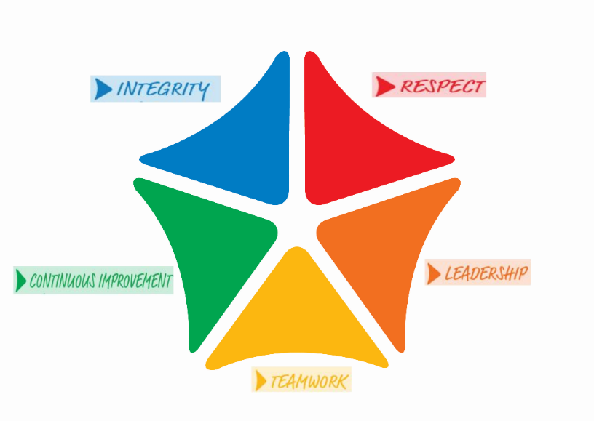NR TAFE is committed to an inclusive, high performance culture that places the needs of the students and the public at the centre of all that we do.

Position Overview

This position is primarily responsible for coordinating and providing specialist advice to managers and workers on injury management processes, including workers compensation claims. This position will also provide advice and support to ensure compliance with the *Work Health and Safety Act 2020* (WA), ***Workers Compensation & Injury Management Act 2023*** and other relevant legislation. This position will initiate, develop and implement WHS solutions, policies and procedures and coordinate programs and projects related to health, safety and employee wellbeing.

Position Responsibilities

# Workers Compensation / Injury Management

1. Coordinates and oversees workers compensation cases and acts as the College’s contact to the insurer, rehabilitation providers and health care professionals to contribute towards a focus on early intervention and assists in the development & implementation of return to work programs.
2. Provides specialist advice to staff, managers and supervisors on workers compensation and injury management, as well as coordinate the planning and evaluation of Work Health and Safety training programs, strategies and initiatives.
3. Monitor and coordinate the department’s workers compensation and injury management service for compensable and non-compensable cases including complex case management and return to work programs.
4. Ensures that the College meets its obligations under the *Workers Compensation & Injury Management Act 2023*.

# Development of Policy and Procedures

1. Initiates and coordinates the development and implementation of general work, health, safety and employee wellbeing policies and programs in accordance with College objectives and values.
2. Develops policies and procedures to ensure that the College meets all the statutory requirements relating to *Work Health and Safety Act 2020* (WA), regulations, codes of practice, the hierarchy of control and other relevant legislation. This includes monitoring, undertaking and providing advice on hazard and incident reporting and investigations.
3. Reviews WHS policy, procedures, guidelines and other WHS reference material for the whole of the College.

# Safety Procedures

1. Provides specialist advice on WHS issues and interpretation of relevant aspects of WHS Legislation including hazardous substances and dangerous goods.
2. Develops, reviews and maintains emergency procedure manuals.
3. Develops and maintain generic evacuation procedures across the College in consultation with key stakeholders at each campus.
4. Investigates WHS incidents, trends and risks, working collaboratively to improve the management of and overall mitigation of risks.
5. Contributes to the planning and conduct of safety audits and makes recommendations to continuously improve processes and outcomes, in accordance with the organisational audit plan.

# Training

1. Develops, implements and maintains WHS related training/awareness programs for College staff and assists workers and managers to understand the applicable regulatory requirements of their environment, including injury management, first aid officer, fire warden and emergency response training and undertaking risk assessments.
2. Determines other training as required for staff identified as being at risk due to the type of duties they carry out.
3. Encourages a safety culture within the College by providing technical knowledge, practical assistance and relevant safety education through a collaborative approach with College staff and managers.

# Coordination/Reporting

1. Coordinates the management/rectification of risk assessment findings across North Regional TAFE.
2. Coordinates the relevant electronic safety systems, such as hazard reporting, hazardous chemicals and workplace inspections.
3. Coordinates the WHS Committee meeting between management and Heath and Safety Representative and administrative functions.
4. Coordinates nominations and training across the College for Heath and Safety Representatives.
5. Develops and implements College WHS performance strategies.
6. Reports on the College’s WHS performance and maintains relevant database systems.

# Other duties

1. Undertakes relevant WHS related projects and tasks as required.
2. Performs other duties as directed.

Selection Criteria

# Essential Criteria

1. Proven knowledge and experience in the implementation, management and maintenance of an WHS Management System, as well as Workers Compensation and Injury Management.
2. Demonstrated knowledge and understanding of WHS legislation, regulations, Codes of Practice and Standards and how they impact on employment and service delivery.
3. Strong interpersonal, communication and negotiation skills, with the ability to establish, manage and maintain productive business relationships and partnerships with staff and relevant stakeholders.
4. Demonstrated ability to collect, analyse and present information including the proficient use of the full Microsoft Office Suite applications.
5. Current knowledge and commitment to Equal Opportunity and wok health and safety in all aspects of employment and service delivery.

Desirable

1. Tertiary qualification in Work Health and Safety or a related field.

# Appointment Factors

|  |  |
| --- | --- |
| **Location:** | North Regional TAFE Campus |
| **Accommodation:** | Not applicable |
| **Allowances:** | As per Award. |
| **Travel:** | Travel to and work at other campuses or sites will be required as the need arises. |

**Special Conditions**

**National Police History Check:**

All new staff being appointed to North Regional TAFE are required to provide a National Police History Check prior to commencing duty. All applications must be directed to the “Screening Unit” at the Department of Education and Training

**Working With Children Check (WWC):**

All new staff appointed to North Regional TAFE in “child-related work" are required to provide a WWC Check prior to commencing duty. If you receive a Negative Notice or an Interim Negative Notice you will be deemed to have repudiated your contract and your employment will cease.

**Current WA ‘C’ Class Driver’s Licence**

All new staff being appointed to North Regional TAFE are required to have a current WA ‘C’ Class Licence as staff will be required to travel between campuses, from time to time. For staff appointed from outside Western Australia, you must apply for a WA driver’s licence within three (3) months of becoming a resident of WA.

**Prescribed Legislation and Regulation**

As an employee of the Western Australian public sector you have specific obligations to the community of Western Australia and your colleagues. In addition to the prescribed industrial agreement, your employment is governed by the following:

Public Sector Management Act (1994) and Regulations Vocational Education and Training Act (1996)

Public Sector Code of Ethics

North Regional TAFE’s Code of Conduct Equal Opportunity Act (1984)

Work Health and Safety Act (2020) Internet Terms and Conditions of Use

Employee Software and Compliance Statement North Regional TAFE policies and procedures

# CERTIFICATION

The details contained in this document are an accurate statement of the position’s responsibilities and requirements.

|  |  |  |  |
| --- | --- | --- | --- |
| Employee | | Executive Director | |
| Name: |  | Name:  Signature: | Chantal Adams |
| Date: |  | Date: | 18 November 2024 |