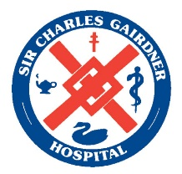

5 NMHS Values
Please supply an example below of how you have displayed each of the 5 NMHS Values in clinical practice during your work history. We have outlined the NMHS values and added the Behavioural expectations under each value, please complete the section below with your example in no more than 200 words per example.
This response will be factored into your suitability for the position of a SCGOPHCG Registered Nurse

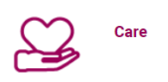
We show empathy, kindness and compassion to all.
Example:

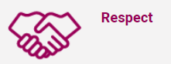
We are inclusive of others and treat everyone with courtesy and dignity.
Example:

We strive for excellence and are courageous when exploring possibilities for our future.
Example:

We work together as one team in a spirit of trust and cooperation.
Example:

We are honest and accountable and deliver as promised.

Example:

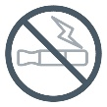
We are proud to be a smoke-free site.
Thank you for not smoking or vaping in any buildings or on our grounds.

This document can be made available in alternative formats on request.
© North Metropolitan Health Service 2022

