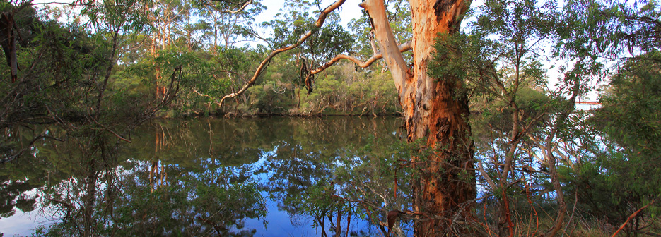

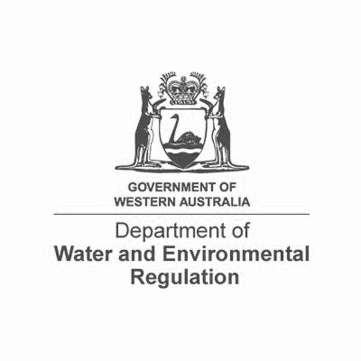

***Position Description***

|  |  |  |  |
| --- | --- | --- | --- |
| ***Position Title:*** *Senior Environmental Officer* | | ***Classification Level:*** *SC Level 3* | |
|  |  |  |  | |
| ***Position Number:*** *Pool Ref 0521A* | | ***Reports to:*** *Manager Licensing (Sector TBC)* | | |
|  |  | |
| ***Directorate / Division:*** *Regulatory Services* ***/*** *Industry Regulation* | | ***Supervises****: NIL* | | |
|  |  | |
| ***Branch / Section:*** *Process/Resources/Waste Industries TBC* | | ***Location:*** | | |
|  | |  | | |

*Role summary*

Assesses and/or project manages the assessment of applications for works approvals and licences under Part V, Division III of the *Environmental Protection Act 1986*. Determines applications under delegated powers and provides specialist scientific advice to a range of stakeholders.

Develops and/or provides input into the development of policy, guidance and process to support the delivery of the regulatory framework under Part V of the *Environmental Protection Act 1986*.

Manages and/or supports the resolution of contentious issues and provides oversight and input to the operational environmental management of premises subject to a works approval or licence. Provides a support role for compliance programs on prescribed premises.

***Responsible for:***

Relevant to the level of skill and experience, working independently with minimal direction to:

* Make determinations on and related to, allocated works approval and licence applications under Part V, Division III, of the *Environmental Protection Act 1986* and the *Environmental Protection Regulations 1987*, under delegated authority.
* Assess and/or project manage the assessment of applications and operations at prescribed premises in line with target timeframes where possible.
* Lead and/or support project teams on policy, technical guidance and process development, legislative and regulatory reform and business system development and improvement.
* Manage and/or support the resolution of contentious issues and provide oversight and input into environmental regulation and management issues associated with prescribed premises.
* Review and actioning of statutory submissions required by Part V instruments, within target timeframes where possible.
* The development, maintenance and sharing of scientific expertise to improve knowledge and build capability throughout the Branch and wider Department. Provision of scientific advice and support to internal and external stakeholders including participation in and membership of State and/or National scientific groups as required.
* Actively engage in change/improvement programs and propose solutions to continually improve the delivery of the Part V licensing function.
* Support the Manager Licensing and wider Department in recruitment, training, coaching and mentoring.
* Applying relevant safety procedures / guidelines and equal opportunity principles to performance of work.
* Other duties as required.

***Work related requirements***

The following is to be read in the context of the preceding sections of this document.

*Essential*

1. Demonstrated ability to plan and manage projects, project outcomes and to monitor individual and project performance.
2. Demonstrated ability to work autonomously or part of a team, make operational decisions and implement strategies to meet priorities, deadlines and departmental objectives.
3. Demonstrated ability to understand and apply legislation, research and critically analyse complex issues and to develop, review and implement policy, process and procedure.
4. Demonstrated ability to perform advanced environmental assessments and review environmental assessment and licensing documents produced by others.
5. Demonstrated experience in mentoring and supporting staff and encouraging a work environment which transfers knowledge and skill with a commitment to self-learning and professional development.
6. Demonstrated ability to communicate effectively and provide a senior level of representation and negotiation.
7. Bachelor of Science or equiavalent. Candidates possessing International qualifications must provide assessment by Overseas Qualification Assessment Unit (OQU) from Department of Workforce Development and Training WA or OQU assessment from other State.

|  |
| --- |
| ***Our Values***    Our values underpin everything we do, they guide the way we conduct our work, how we engage with each other and deliver services to our customers. The ability to demonstrate how you will apply our values is important to us. |

***Special Equipment/Requirements***

Current driver’s licence, accepted in Western Australia, to enable the undertaking of field work.