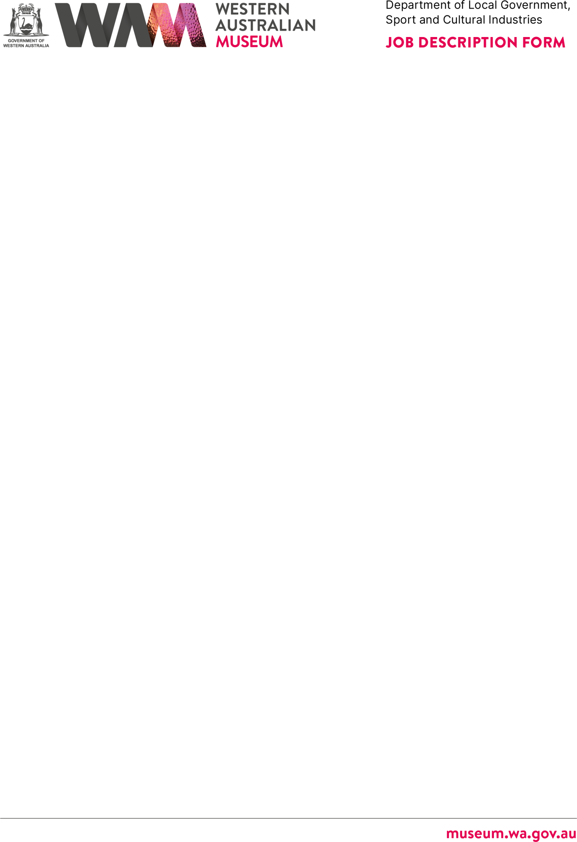

ABOUT THE WESTERN AUSTRALIAN MUSEUM

The WA Museum’s mission is to inspire curiosity to explore the past, question the present and shape the future.

Our work is diverse and collaborative; it is local, national and global. We aspire to be a valued, used, and admired organisation by all Western Australians and the world.

WA Museum manages eight locations throughout Western Australia, including the award winning Boola Bardip in the Perth Cultural Centre. We have a team of dedicated curators undertaking a wide range of research and caring for more than eight million objects for the benefit of future generations.

The Museum is a Statutory Authority within the Department of Local Government, Sport and Cultural Industries (DLGSC).

DETAILS
Position Title | Position Number
Operations Manager | 13160
Classification Level | Award/Agreement
Level 5 (L5) | Public Service Award 1992 / PSGO CSA GA
Directorate | Branch/Team
Regions Directorate | Goldfields / Operations
Physical Location/s
Museum of the Goldfields, Kalgoorlie

REPORTING RELATIONSHIPS

Position reports to
Regional Manager, L6

Positions reporting to this position
- Supervisor, ATT/S

PURPOSE OF THE POSITION

Under the limited direction of the Regional Manager, this position:
- Provides leadership and direction through applying and monitoring human and physical resources to the site’s daily operations.
- Develops and maintains operational networks through effective liaison with visitors, stakeholders, community, and special interest groups and promotes community support for the organisation’s goals and strategies.
- Supports the site’s visitor-oriented experiences including programs, events, outreach, marketing, and online services.
- Individuals undertake their duties within the Department’s Code of Conduct, policies and procedures, and relevant Government legislation.

STATEMENT OF DUTIES

- Manage the daily Visitor Services operations of the site through effective leadership, resource management, planning and evaluation.
- Manage the site buildings, including understanding the impact of exhibition and building maintenance scheduling on the site’s daily visitor operations and services in liaison with the Regional Manager and Facilities Manager.
- Ensure the security of the WA Museum’s collections on site and observe WA Museum Conservation standards for collections care.
- Contribute to the site’s visitor-oriented experiences including exhibitions, public and education programs, events, outreach, marketing, and online services.
- Represent the Western Australian Museum in regional forums including visitor, museum, or heritage services.
- Act as Regional Manager when the Regional Manager is on leave or absent from the venue.
- Assist with the development of the Site’s operational plans, projects and associated budgets.
- Other duties as required with respect to the skills, knowledge and abilities of the employee.
- Work outside normal business hours and on weekends is required. Some intra-state travel is required.
- Other duties as required with respect to the scope of the position.

WORK RELATED REQUIREMENTS

Essential
- Demonstrated experience in a museum, gallery, cultural heritage, arts or tourism environment and a sound understanding of the role of museums in the community.
- Demonstrated experience in effective team management and the capacity to lead and work with a small and creative team
- Demonstrated interpersonal skills including the ability to communicate with staff, government agencies, community groups and other organisations.

- Ability to manage conflicting priorities, work under tight timelines and resolve challenges to meet organisational outcomes.
- Ability to plan, develop and implement visitor-oriented programming such as exhibitions or events.
- Ability to apply the principles of risk management, work health and safety, and equity and diversity principles and practices in the context of this position.

Desirable
- Experience in working with youth, people with disabilities, and the ability to interact sensitively with indigenous people and diverse cultural groups.
- Qualifications in museum or arts management, business development, or tourism management.

SPECIAL CONDITIONS

  - Work outside of normal business hours and on weekends is required.
  - Some intrastate travel is required.
  - State allowances and conditions applicable – District Allowance.
  - A current National Police Certificate will be required prior to commencement of employment.

APPOINTMENT IS SUBJECT TO

  - Eligibility to Work in Australia.
  - A current (within 6 months) Police Clearance Certificate will be required.

TRAINING

  - Complete induction within three months of commencement.
  - Complete any training specific to the role required by Departmental or WA Museum policy.
  - Complete the Department’s Accountability and Ethical Decision-Making training within six months of appointment.

