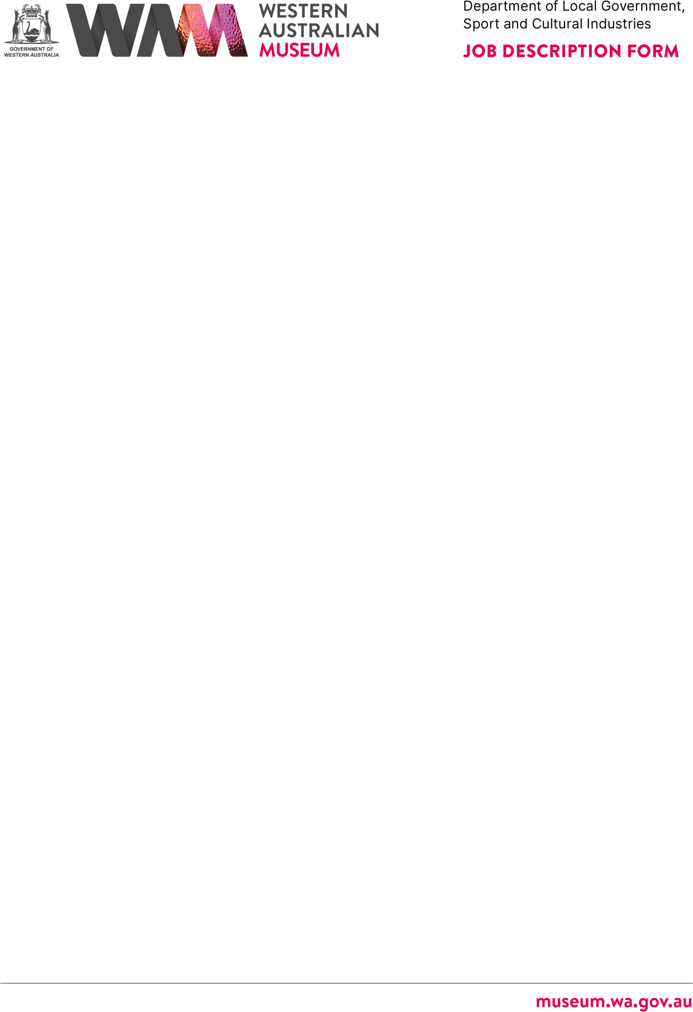

ABOUT THE WESTERN AUSTRALIAN MUSEUM

The WA Museum’s mission is to inspire curiosity to explore the past, question the
present and shape the future.

Our work is diverse and collaborative; it is local, national and global. We aspire to be valued, used and admired organisation by all Western Australians and the world.

WA Museum manages eight locations throughout Western Australia, including the award winning Boola Bardip in Perth Cultural Centre. We have a team of dedicated curators undertaking a wide range of research and caring for more than eight million objects for the benefit of future generations.

The Museum is a Statutory Authority within the Department of Local Government, Sport and Cultural Industries (DLGSC).

DETAILS

Position Title Position Number
History Collections Curator 17187

Classification Level Award/Agreement
Specified Calling Level 2 (SCL2) Public Service Award 1992 / PSGO CSA GA

Directorate Branch/Team
Collections and Research Culture and Communities / History

Physical Location/s
Collections and Research Centre, Welshpool

REPORTING RELATIONSHIPS

Position reports to
Head of History, SCL3

Positions reporting to this position
- Nil

PURPOSE OF THE POSITION

This position contributes to the development, documentation, and interpretation of the History Department’s collections, with a particular focus on the management of physical and digital collections, associated information systems and collection storage areas. It conducts research and significance assessments of material culture related to Western Australian social history and contributes to the development and implementation of museum policies and procedures. Additionally, this position contributes to the development of exhibitions and public programs, and liaises with individuals, community groups and other cultural and research organisations.

STATEMENT OF DUTIES

- Contributes to the development and implementation of collection management policies and procedures, including those that address acquisitions, documentation, storage, security, risk assessment, disaster planning, artefact movements, loans and collection access.

- Manages the History Department’s use and application of collection management system databases in consultation with the Head of Department and other relevant staff, ensuring data integrity.
- Manages the storage of the History Department’s physical and digital collections, in consultation with the Head of Department and Curators.
- Undertakes significance assessments of material culture.
- Facilitates appropriate access to History collections and information and represents the Museum in community and professional networks.
- Assists with the development of exhibitions, online content and public programmes related to Western Australian social history.
- Trains and supervises volunteers and practicum students.
- Other duties as required.

WORK RELATED REQUIREMENTS

Essential
- Tertiary qualification in a relevant field.
- Demonstrated knowledge and significant experience in contemporary management of material culture collections.
- Demonstrated knowledge and significant experience using collection management database systems.
- Demonstrated skills and knowledge in the significance assessment of material culture.
- Significant research skills and experience, including the ability to present findings in a variety of formats to diverse audiences.
- Knowledge of the development of contemporary exhibitions and other interpretive programmes.
- Highly developed communication, interpersonal and negotiating skills, including the ability to manage volunteers and work with community groups, cross-disciplinary project teams and stakeholder communities.

SPECIAL CONDITIONS

  - A current “C” Class drivers’ licence, or equivalent.
  - Tertiary qualification in a relevant field.
  - Work outside normal business hours may be required on occasion.

APPOINTMENT IS SUBJECT TO

  - Eligibility to Work in Australia.
  - A current (within six months) National Police Clearance Certificate.

