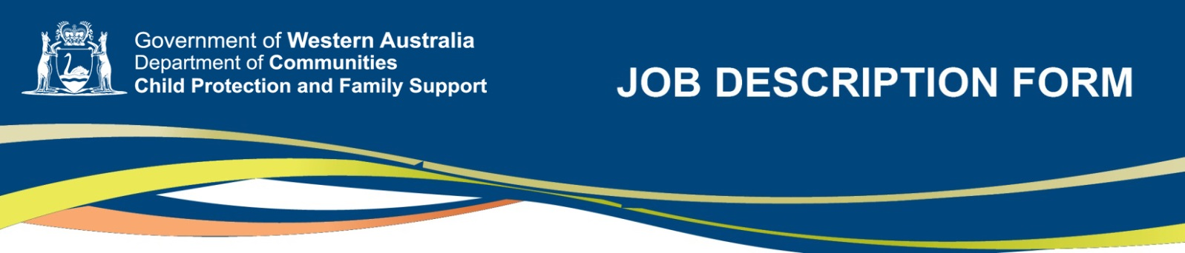

Section 1 – POSITION Identification

Position number: | 009915
Title: | Leader Child Protection
Classification: | Specified Calling Level 3
Directorate: | Country Services
Division: | Murchison
Section: | Murchison
Award/Agreement: | Public Service Award 1992; relevant Public Service and Government Officers General Agreement
Location of position: | Geraldton

SECTION 2 – REPORTING RELATIONSHIPS
Department for Child Protection and Family Support

REGISTERED COPY
July 2017
POSITION TITLE | CLASSIFICATION
Assistant District Director | Specified Calling Level 4
Reports to

This position | Specified Calling Level 3

Positions under direct supervision:
Title | Classification
Nil

SECTION 3 – DEPARTMENT VALUES
- We value respect  - We value openness | - We value team work  - We value responsiveness

SECTION 4 – STATEMENT OF RESPONSIBILITIES

The Leader Child Protection works as part of the Family Support Network in the areas of child protection and family support and is responsible for:

Representing the Department as a core member agency of the Family Support Network in partnership with the community service sector to support vulnerable children, young people and families.

Providing specialist consultation, support and advice on the safety and wellbeing of children, young people and families involved with the Family Support Network and making decisions regarding referral and intake to the Department.

Managing Family Support Network referrals to the Department.

Providing leadership in the Family Support Network and maintaining effective relationships with agencies and staff.

Responding to concerns regarding the safety and wellbeing of children in applying the provisions of the Children and Community Services Act 2004.

Participates in assessment and complex case work activities, as required.

Providing direction and intervening in child protection case work matters to promote the safety and wellbeing of children.

Reporting to the District Director on the activities of the Family Support Network.

Liaising with other Team Leaders and District/Departmental staff.

sECTION 5 – KEY RESPONSIBILITIES
 | Key Responsibility Area & Related Duties
1 | TEAM FUNCTIONS:  Child Protection  Reviews reported concerns about a child’s wellbeing by making enquiries under Section 31 of the Children and Community Services Act 2004, and makes individual assessment to determine whether action is required to safeguard or promote the child’s wellbeing.  Conducts and/or leads assessments and investigations as part of the Family Support Network Team on behalf of the Department under Section 32 of the Children and Community Services Act 2004 to determine what action should be taken, including further assessments, to determine parental or carer capacity to protect the child.  Takes intervention action under Section 32 of the Children and Community Services Act 2004 if a child is in need of protection under Section 28 and collects evidence, prepares documents and participates in protection proceedings as required under the Children and Community Services Act 2004, Part 4, Division 2 and 3 and Part 5.  Undertakes family and parental assessments with the Family Support Network Team to determine parental or carer capacity to protect child/ren and makes decisions to refer cases to the Department as required.  Provides leadership and consultation to Family Support Network staff on matters concerning the care, safety and protection of children.  Makes decisions regarding referrals to the Department services, including Responsible Parenting Services – Best Beginnings and Parent Support.  Liaises with the District Director in providing a high level of professional practice on behalf of the Family Support Network Team to improve the outcomes for the safety and wellbeing of children and other vulnerable people.
2  3 | Family Support  Provides recommendations to the Family Support Network Team in relation to child and family assessments so as to provide support and/or treatment services for families who come to the attention of the Network.  Provides leadership and consultation to Family Support Network team members in providing planning and services to families that will address child protection issues and strengthen family functioning.  Provides leadership and consultation to Family Support Network team members in developing family capacity to provide safe environments for children and other vulnerable people.  Liaises with the District Director regarding delegation of field/community work in the area of family support.  Interagency and Community Collaboration  Establishes and maintains strong collaborative relationships and shares information with Government and non-government agencies that may have a statutory role or are providing a service to the Department in protecting children and assisting with their education and health.  Liaises with appropriate cultural and Indigenous services and communities that provide an identity for the child/ren or family that the Department is working with towards a goal of strengthening family functioning.
Liaises with the Departments contracted service providers and other agencies on behalf of the Family Support Network and/or District Director including planning forums and interagency meetings.

Implements activities as part of a new program, in partnership with community service agencies and contributes to on-going program development.

Provides information and education to local community agencies regarding the role of the Department.

4 | Administration  Ensures the maintenance of electronic client records and case management data.  Provides mentoring, supervision and training to District staff, as required.  Contributes to Departmental research and evaluation of services as required.  Manages Departmental and Government resources in accordance with Government and Departmental policy.  Complies with the Department’s Administrative Manual and the Case Practice Manual.
5 | Other Duties  Ensures outputs are delivered in accordance with Departmental statutory responsibilities, policies and procedures.  Contributes to the development and implementation of policy and program framework and manages local projects.  Ensures that Departmental client information systems are maintained according to departmental guidelines.  Participates in emergency management and response duties as required.  Performs other duties as required.

SECTION 6 – WORK RELATED REQUIREMENTS

ESSENTIAL
Demonstrated:
- Advanced skills and understanding of contemporary casework and practice models/methods and leadership regarding their application in working with children, families and communities.
- Sound understanding of contemporary issues and challenges in the field of child protection and family support approaches to enhancing child safety and wellbeing.
- Ability to consult and collaborate with key internal and external stakeholders.
- Well-developed assessment, analytical and interpersonal skills, including the ability to work as part of a multi-disciplinary team.
- A tertiary qualification in social work, psychology or a relevant human service area.

SECTION 7 – ESSENTIAL ELIGIBILITY REQUIREMENTS

The occupant of this position will require the following prior to appointment:

Current C or A class drivers licence
Departmental Record Check
Criminal Record Check
Working with Children Check

SECTION 8 – certification

The details contained in this document are an accurate statement of the duties, responsibilities and other requirements of the position.

DELEGATED AUTHORITY:
(Director or above)
SIGNATURE:
NAME:
POSITION TITLE:
DATE:

